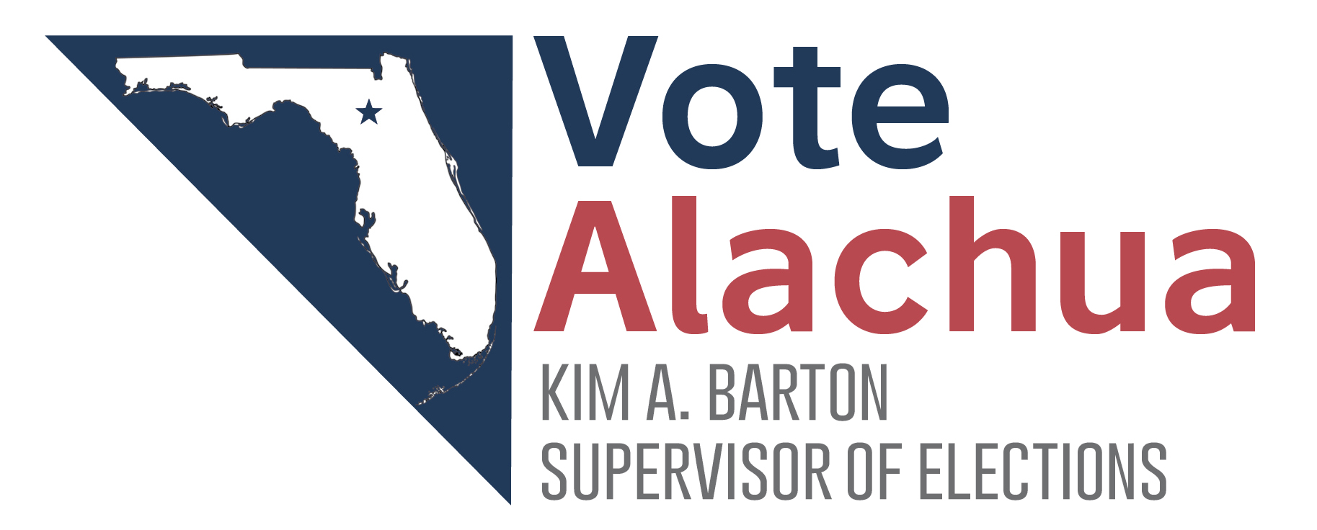
Qualifying Fees and Petition Method Information
2022 Alachua County Offices

Election Dates
- Primary Election: August 23, 2022
- General Election: November 8, 2022
Qualifying Dates
- Representative in Congress, State Attorney, Public Defender, Justice of Supreme Court, District Court of Appeal, Circuit Court Judge (including write-ins)
  - Noon, Monday, April 25, 2022 – Noon, Friday, April 29, 2022
- State Senator, State Representative, County and Multi-County Special Districts (including write-ins)
  - Noon, Monday, June 13, 2022 – Noon, Friday, June 17, 2022
Qualifying Fees
Major party candidates will pay a fee equal to six percent (6%) of the salary of the office sought. This includes the two percent (2%) party assessment. Minor party candidates will pay a fee equal to four percent (4%) of the salary of the office sought plus any applicable party assessment. No Party Affiliation and Nonpartisan candidates will pay a fee equal to four percent (4%) of the salary of the office sought. The salary is set after July 1.

Petition Method Information
To qualify by petition method, all candidates (except Soil & Water Conservation District candidates) shall obtain the signatures of a number of qualified voters equal to one percent (1%) of the number of registered voters at the last general election. In the 2020 General Election, the total of registered voters was 190,451.

In Alachua County, candidates will need to submit 1,905 valid signatures to qualify by the petition method. Candidates must pay by campaign check written to Supervisor of Elections in advance the sum of $190.50 (10 cents for each signature checked), unless the candidate has filed an oath of undue burden or is filing in a special district.

Judicial, state attorney and public defender candidates must submit petitions to the Supervisor of Elections office before noon on March 28, 2022.

Federal, statewide, multi-county, county and district candidates must submit petitions to the Supervisor of Elections office before noon on May 16, 2022.

2022 Alachua County Commission Districts
District | Incumbent | Petition Signatures Required to Qualify | Major Party Qualifying Fee | No Party Affiliation (NPA) Qualifying Fee
District 2 | Marihelen Wheeler | 1,905 | $4,699.98 (2020) | $3,133.32 (2020)
District 4 | Ken Cornell | 1,905 | $4,699.98 (2020) | $3,133.32 (2020)

Minor Party Candidates: Minor party candidates will pay the same qualifying fee as candidates with No Party Affiliation, plus any applicable party assessment.
Residency Requirements: Must be a resident of the District for which he/she runs at the time of qualifying. Write-in candidates must reside in the district they seek to represent at the time of qualification. Candidate must be a qualified elector of Alachua County per F.S. 99.021.

2022 Alachua County School Board
District | Incumbent | Petition Signatures Required to Qualify | No Party Affiliation (NPA) Qualifying Fee
District 1 | Tina Certain | 1,905 | $1,543.68 (2020)
District 3 | Gunnar F. Paulson | 1,905 | $1,543.68 (2020)
District 5 | Robert P. Hyatt | 1,905 | $1,543.68 (2020)

Minor Party Candidates: Minor party candidates will pay the same qualifying fee as candidates with No Party Affiliation, plus any applicable party assessment.
Residency Requirements: Must be a resident of the District for which he/she runs at the time of qualifying. Write-in candidates must reside in the district they seek to represent at the time of qualification. Candidate must be a qualified elector of Alachua County per F.S. 99.021.

2022 Alachua County Judiciary
Group | Incumbent | Petition Signatures Required to Qualify | No Party Affiliation (NPA) Qualifying Fee
Group 1 | Susan Miller-Jones | 1,905 | $6,072.88 (2020)
Group 3 | Walter M. Green | 1,905 | $6,072.88 (2020)
Group 5 | Thomas M. Jaworski | 1,905 | $6,072.88 (2020)

Requirements: Candidate must be a qualified elector of Alachua County per F.S. 99.021. Candidates must be, and have been, for the preceding 5 years, a member in good standing of the bar of Florida prior to qualifying for election per F.S. 34.021.

2022 Alachua County Soil and Water District
Seat | Incumbent | Petition Signatures Required to Qualify | No Party Affiliation (NPA) Qualifying Fee
Seat 1 | John Chamberlain | 25 | $25.00
Seat 3 | Kaithleen Henandez | 25 | $25.00
Seat 5 | Archie Matthews | 25 | $25.00

Effective January 1, 2008, FS 99.061 and 99.095(2) provide a uniform method of qualifying for special district offices, which includes either paying a qualifying fee of $25 which is not required to be drawn from the campaign account, or qualifying by the petition method by obtaining 25 signatures.

